**Experiment 13**

**Dhruv Singhal || 500075346 || R177219074 || AIML || Sem5**

**Random Forest Classfier**

# Importing required libraries

In

[1]:

**from**

sklearn

.

datasets

**import**

make_classification

**from**

sklearn

.

model_selection

**import**

train_test_split

**from**

sklearn

.

ensemble

**import**

RandomForestClassifier

**import**

seaborn

**as**

sns

**import**

pandas

**as**

pd

**import**

matplotlib

.

pyplot

**as**

plt

**import**

warnings

warnings

.

filterwarnings

(

'ignore'

)

# Data creation

Creating Dataset using make_classfication with 5000 sample points and 5 classes with 20 number of features in which 10 are informative features and 5 are redundant features and shuffling is turned ON

In

[2]:

X

,

y

**=**

make_classification

(

n_samples

**=**

5000

,

n_classes

**=**

5

,

n_features

**=**

20

,

n_informative

**=**

10

,

n_redundant

**=**

5

,

shuffle

**=**

**True**

,

random_state

**=**

0

)

X

**=**

pd

.

DataFrame

(

X

)

y

**=**

pd

.

DataFrame

(

y

)

# Preprocessing & Visualization

since we have created dataset using make_classfiocation , it by default make dataset's mean tending to 0 and Standard Deviation to 1 which doesn't require any preprocessing. For Visualization varition of values of X(with 20 features) and y's distplot to observe y's vartion of values and distplot of X to check if any pre processing is to be required

In

[3]:

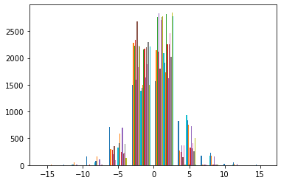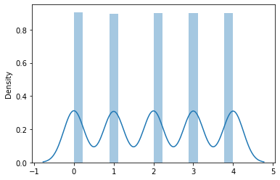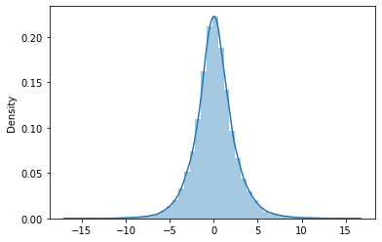

plt

.

hist

(

X

)

plt

.

show

()

sns

.

distplot

(

y

)

plt

.

show

()

sns

.

distplot

(

X

)

plt

.

show

()

feature extraction preprocessing, correlation matrix to check if any pre processing is to be required

In

[4]:

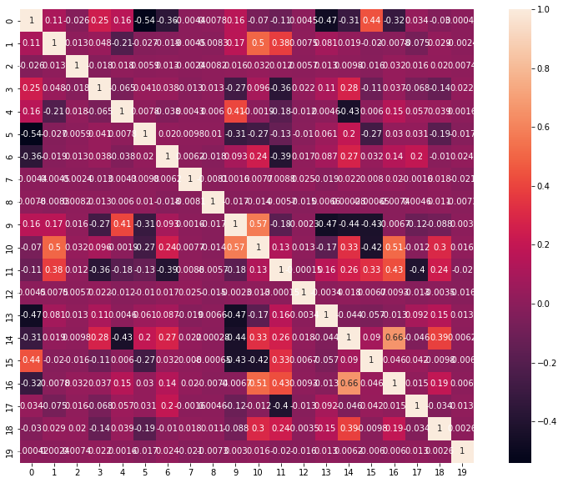

_

,

graph

**=**

plt

.

subplots

(

figsize

**=**

(

15

,

10

))

sns

.

heatmap

(

X

.

corr

()

,

annot

**=**

**True**

,

ax

**=**

graph

,

square

**=**

**True**

)

plt

.

show

()

# Model Building

Random forest classifier creates a set of decision trees from a randomly selected subset of the training set. It is basically a set of decision trees from a randomly selected subset of the training set and then It collects the votes from different decision trees to decide the final prediction. Assuming dataset has “m” features, the random forest will randomly choose “k” features where k < m. Now, the algorithm will calculate the root node among the k features by picking a node that has the highest information gain. After that, the algorithm splits the node into child nodes and repeats this process “n” times. Now we have a forest with n trees. Finally, perform bootstrapping, ie, combine the results of all the decision trees present in the forest.

We have directly used the in built function of sklearn library i.e., from sklearn.ensemble import RandomForestClassifier which directly imports this classifier

# Compile & Train

Firstly splitting the input dataset into training and test parts following which training set is passed through RandomForestClassifier and is fitted to it. and predicting over the test test to check the model performance.

In

[5]:

X_train

,

X_test

,

Y_train

,

Y_test

**=**

train_test_split

(

X

,

y

,

test_size

**=**

0.20

,

random_state

**=**

42

)

model

**=**

RandomForestClassifier

()

model

.

fit

(

X_train

,

Y_train

)

Y_pred

**=**

model

.

predict

(

X_test

)

print

(

"train Accuracy:"

,

model

.

score

(

X_train

,

Y_train

))

print

(

"test Accuracy:"

,

model

.

score

(

X_test

,

Y_test

))

train Accuracy: 1.0 test Accuracy: 0.79

# Result

since training is giving 100% accuracy and in testing it is giving 79% accuracy so it's clearly overfitting so to overcome this we are using k fold cross validation and hyperparameter tuning to improve the overall score and generate generalizesd model and knowing which hyperparameter combination gives best overall score

In [6]: *#Cross Validation without Hyper parameter tuning* **from** sklearn.model_selection **import** KFold **from** sklearn.model_selection **import** cross_val_score clf **=** RandomForestClassifier(max_depth**=**10, random_state**=**0) kf**=**KFold(n_splits**=**7)

score**=**cross_val_score(clf, X, y, scoring**=**'accuracy',cv**=**kf) print("Cross Validation Scores are {}".format(score)) print("Average Cross Validation score :{}".format(score.mean()))

Cross Validation Scores are [0.78461538 0.77062937 0.80672269 0.82633053 0.78431373 0.78011204

0.79411765]

Average Cross Validation score :0.7924059134143168

In [7]: **from** sklearn.model_selection **import** GridSearchCV tuned_parameters **=** [{'n_estimators':[10,20,40,100],'criterion':['gini', 'entropy'], 'max_features':['auto', 'sqrt', 'log2'],'bootstrap':[**True**,**False**]}] clf**=**GridSearchCV(RandomForestClassifier(),tuned_parameters,scoring**=**('accuracy'),verbose**=**3) clf.fit(X,y)

print("Best parameters set found on development set:") print()

print(clf.best_params_) print() print("Best Score:",clf.best_score_)

= 0.3s

[CV 1/5] END bootstrap=False, criterion=gini, max_features=auto, n_estimators=40;, score=0.804 total time

= 0.7s

[CV 2/5] END bootstrap=False, criterion=gini, max_features=auto, n_estimators=40;, score=0.805 total time

= 0.7s

[CV 3/5] END bootstrap=False, criterion=gini, max_features=auto, n_estimators=40;, score=0.813 total time

= 0.7s

[CV 4/5] END bootstrap=False, criterion=gini, max_features=auto, n_estimators=40;, score=0.794 total time

= 0.8s

[CV 5/5] END bootstrap=False, criterion=gini, max_features=auto, n_estimators=40;, score=0.804 total time

= 0.8s

[CV 1/5] END bootstrap=False, criterion=gini, max_features=auto, n_estimators=100;, score=0.810 total tim e= 2.0s

[CV 2/5] END bootstrap=False, criterion=gini, max_features=auto, n_estimators=100;, score=0.827 total tim e= 1.9s

[CV 3/5] END bootstrap=False, criterion=gini, max_features=auto, n_estimators=100;, score=0.837 total tim e= 2.0s

[CV 4/5] END bootstrap=False, criterion=gini, max_features=auto, n_estimators=100;, score=0.805 total tim e= 2.0s

[CV 5/5] END bootstrap=False, criterion=gini, max_features=auto, n_estimators=100;, score=0.821 total tim

2

Best parameters set found on development set:

{'bootstrap': False, 'criterion': 'gini', 'max_features': 'log2', 'n_estimators': 100}

Best Score: 0.8214 Now the overall score is 82.14% accuracy which is above the testing accuracy without cross validation

In [ ]: